Personalise your policy
Health and Wellbeing Policy
<Insert school name>
<Insert school logo>
RATIONALE
Health promotion practices such as healthy eating, physical activity and sun protection are fundamental to good health and contribute to lifelong health and wellbeing. For children, health status and academic achievement are directly connected. Schools make a difference to help children learn healthy behaviours and establish lifelong behaviours and can contribute to healthy growth and weight.
Our policy aims to:
- Create better learning outcomes, health and well-being for students and staff.
- Provide a safe, stimulating and fun place to learn, work and play.
- Nurture a sense of pride and commitment where students, teachers/staff, parents/caregivers, health professionals and community groups collaborate to create and maintain a healthy school community.
- Increase awareness in the school community of the benefits of eating healthy food, being physically active and protecting against UV (ultraviolet) radiation.
- Embed healthy behaviours into our school community using a whole school approach.

OUR COMMITMENT
Curriculum, teaching and learning
<Insert school name> will incorporate health and wellbeing concepts into school curriculum by:
- Providing regular professional development opportunities for teachers and other staff.
- Allocating adequate budget for professional development and curriculum materials
- Ensuring there are regular physical activity and health sessions during teaching periods for years K-10.
- Reviewing and developing activities that will give students the skills to make healthy eating, sun protection and physical activity choices for themselves.
- Developing physical activity opportunities that are in line with national guidelines¹ (for 5 to 17 year olds, a minimum of 60 minutes of moderate to vigorous activity every day).
- Encouraging food-centred activities that are healthful, enjoyable and developmentally appropriate².
- Encouraging parent/carer participation in school based healthy eating and physical activity sessions.
¹Australia's Physical Activity and Sedentary Behaviour Guidelines from Commonwealth of Australia, Department of Health - see www.health.gov.au
For the SunSmart Schools program:
- Incorporating sun safety education as part of the curriculum for at least 3 year levels.
- Educate staff, students and the school community about sun protection by using online learning workshops available on the SunSmart website: www.GenerationSunSmart.com
For Crunch&Sip®:
- Establishing a set time for Crunch&Sip® in most/ all classrooms each day (a list of permitted foods for Crunch&Sip® is available at www.crunchandsip.com.au).
- Encourage all students and teachers to drink water throughout the day and participate in a classroom vegetable & fruit break daily for Crunch&Sip® (For information go to the Crunch&Sip® website: www.crunchandsip.com.au).
2 Refer to the Australian Dietary Guidelines - see www.eatforhealth.gov.au
School organisation, ethos and environment
<Insert school name> will nurture an environment where students will receive consistent messages about health and wellbeing by:
- Motivating and supporting staff to achieve quality outcomes for the students’ health and wellbeing. For example, assigning a school Health and Wellbeing Coordinator.
- Ensuring all students have access to healthy food (including breakfast), compulsory uniform items (e.g. hats) and can participate in physical activities.
- Ensuring that the standards for healthy food and drink choices are consistent with curriculum messages and relevant mandatory policies³, and that these standards apply to canteens and food services, class treats and cooking activities, school camps and excursions.
- Encouraging and supporting parents/ carers to ensure their children eat healthy, varied lunches, snacks and treats at school and that healthy eating practices are reinforced at home.
- Students and families are encouraged to utilise active transport where possible.
For the SunSmart Schools program:
- Requiring students to wear sun protective clothing, including hats (broad-brimmed, bucket or legionnaire style) for all outdoor activities as appropriate.
- Establishing role models within the school community through staff wearing appropriate clothing and hats while on duty and at other outdoor activities and encouraging school visitors to do the same.
- Ensuring that school uniform requirements incorporate sun protective elements such as shirts with collars and longer sleeves, longer style shorts and rash vests for swimming
- Providing shade and ensuring that, where possible, outdoor activities such as sports carnivals take place in shade and are scheduled away from peak UV
- Actively encouraging students to apply water resistant broad spectrum sunscreen [minimum SPF 30+] 20 minutes before commencing outdoor activities.

3 Healthy Food and Drink Policy see www.det.wa.edu.au/healthyfoodanddrink and http://det.wa.edu.au/policies/detcms/policy-planning-and-accountability/policies-framework/policies/healthy-food-and-drink-policy.en?cat-id=3457102
For Crunch&Sip®:
- Providing clean, safe and accessible drinking water available for Crunch&Sip® and reminding students to refill their water bottles throughout the day.
- Encouraging all students to eat a piece of vegetable or fruit in the classroom during a daily designated Crunch&Sip® time and drink water from their own bottle throughout the day.
- Actively finding ways to provide vegetables &/or fruit for Crunch&Sip® for students who do not have access to them. For example, seeking donations of fresh produce from Foodbank or local retailers; allocating available funds to purchase vegetables and fruit.
- When appropriate, staff being seen consuming vegetables & fruit and water to reinforce the Crunch&Sip® message.

Partnerships and services
<Insert school name> will develop strong community links to the school by:
- Providing information to parents and staff about the Crunch&Sip® and SunSmart programs. For example through newsletters; the school website; during student enrolment; in the school policy and procedures manual.
- Supporting P&C fundraising initiatives that uphold the principles of healthy eating and physical activity.
- Actively seeking opportunities to form partnerships with parents/carers, community groups, health service professionals and agencies to achieve the aims outlined in our Health and Wellbeing Policy.

Our team
<Insert school name> will form a small team to implement our Health and Wellbeing Policy. (Note: These people may be part of an existing group. The representatives below are a suggestion only).

Teacher representative <insert name>

Student <insert name>

Parent <insert name>
Health Service representative <insert name & organisation>

Other <insert name & role>

Evaluation
At the end of each school year, <insert names of reviewers - two members of the above team> will review our Health and Wellbeing Policy to:
- identify our achievements and shortfalls
- recommend a course of action for the forthcoming year
- allow parents and staff to provide comment

DATE SIGNED

Western Australian schools are encouraged to improve the health and wellbeing of students and the school community by using a whole school approach with the ‘Health Promoting Schools Framework’.
Guidelines for Developing your School Health and Wellbeing Policy
The three interrelated components of the Health Promoting Schools Framework are:  - Curriculum, teaching and learning;  - School organisation, ethos and environment; and  - School partnerships and services.  The Framework provides a model to assist with planning and identifying areas that require improvement. | 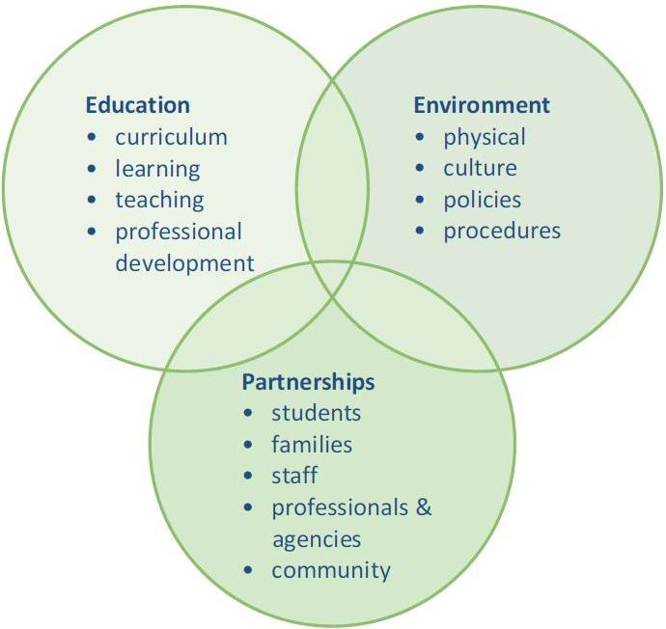  Source: WA Health Promoting Schools Association (Inc.)

A policy will:
- Reassure families, students and school staff that health and wellbeing measures are in place;
- Provide an existent approach to school-based health activities for all members of the school community;
- Establish a framework for deciding what health activities your school will undertake;
- Assist your teachers to meet curriculum requirements and achieve better learning outcomes for their students; and
- Introduce your students to enjoyable activities and programs that will contribute to their lifelong health and wellbeing.

Steps to creating a policy
- Identify a group of interested people. This may be the development of a new team or the enhancement of an existing team/committee. Members may include administrators, teachers, students, canteen representatives, school nurse, parents and health professionals. Allocate a leader or coordinator.
- Identify policy development process and school needs. Consider existing programs, priorities, available resources, compliance with mandated requirements and identify areas of improvement.
- Adapt this health and wellbeing policy template to meet school needs. Gather input from the school and community if possible.
- Build awareness and support. Keep decision makers such as administration and parent committees informed, as well as communicating to students, staff and the community.
- Adopt and implement the policy.
- Maintain, measure and evaluate. Review the policy annual and adapt as necessary.

About Cancer Council WA’s Health and Wellbeing policy template

This template is designed for schools to use as a base or framework when developing a health and wellbeing policy.

This template focuses on nutrition, physical activity and sun protection. Other school health priority areas can be added such as mental health, injury prevention, drug education, relationships and sexual health education etc. It may be appropriate to combine other policies with this one, such as Act-Belong-Commit’s school Mental Health Policy or School Drug Education & Road Aware (SDERA) guidelines.

The highlighted areas in this policy template relate to the SunSmart Schools and Crunch&Sip® programs. Including these components satisfies the requirements of the programs and meets the accreditation criteria for membership.
Inclusion of these clauses in this policy will enable your participation in the Cancer Council WA SunSmart Schools program.
Inclusion of these clauses in this policy will enable your participation in the Crunch&Sip® program.

Contact:
E: schools@cancerwa.asn.au


P: (08) 9212 4333


www.crunchandsip.com.au www.generationsunsmart.com www.cancerwa.asn.au

